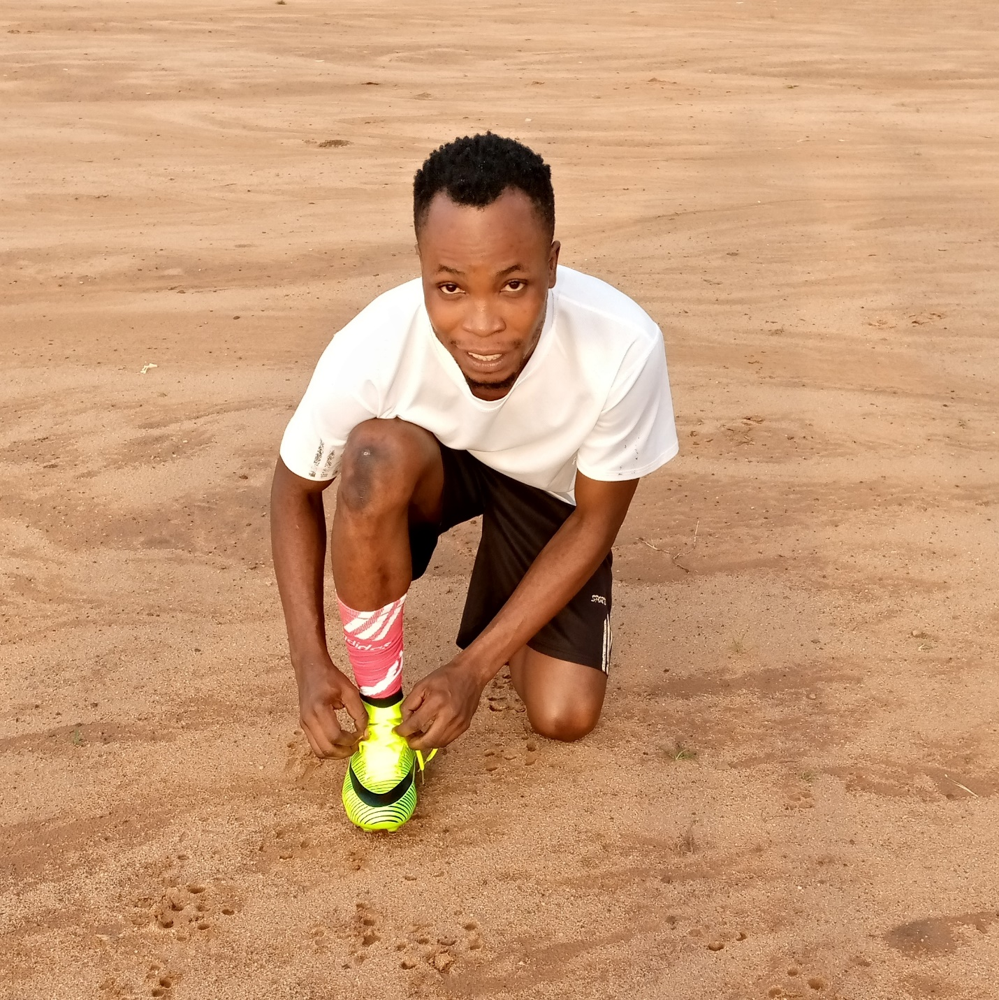

**PERSONAL INFORMATION**

**FIRST NAME- Adekola-Segun**

**LAST NAME-Godwin**

**TELEPHONE NO.- +2348130247119**

**EMAIL- godwinadekolasegun@gmail.com**

**POSITION- Attacking midfielder**

**FOOT- Right foot**

**HEIGHT- 1.70**

**WEIGHT- 60kg**

**STATE- Osun-State**

**NATIONALITY- Nigerian**

**COUNTRY OF BIRTH- Nigeria**

**FORMER CLUBS- Soccer Wizard FC, United FC,**

**AWARDS- Best Player, higher goals scorer, assist leader**

**SCHOOL REPORT**

Technical Ability.

He has ability to:

• bring a ball under control instantly and smoothly

• collect and move in a different direction without stopping the ball completely, yet still maintaining it securely

• develop the technique of receiving a pass at top speed

• not slow down to collect a ball coming on the ground, bouncing, or in the air

• protect the ball by shielding it and developing deception to get rid of opponent

Passing

He has ability to:

• successfully complete short and long range passes

• incorporate all of ball skills, including heading, bending, chipping, and the ability to drive the ball to a partner

• one-touch pass

Dribbling

He has ability to:

• fake, feint, burst past opponents, change directions and speed at will, and break through packed defensive lines

• exhibit quick feet, combined with a sense of comfort under pressure

• to penetrate into space to open opportunities

Heading

He has ability to:

• head at goal after crosses

• heading high, wide, and deep for defensive clearances

• heading balls as a one-touch pass (both into space or to a partner’s feet) to create shooting chances

Finishing

He has ability to:

• use the correct technique of striking the ball in various ways; driving low balls, hitting volleys, half-volleys, half-chances,

chipping, bending, heading, etc..

• finish with chest, heel, toe, and thigh • exhibit composed aggressiveness, swift and secure decision taking at the opportune times (very aggressive and not afraid of

failure)

Tactical Awareness. He incorporates the anticipation, reading, and execution of certain clues that happen during

possession and non-possession of the ball.

In Attack:

• makes himselves available for the ball

• he realizes when it is crucial to offer close support and when to stay away

• he recognizes the proper time to execute “take-overs” and “overlaps

• he has good peripheral vision, recognizing the correct time to switch the ball to the other side of the field

•he has good penetrating vision, allowing them to see and utilize players who are far down the field

• he recognizes the correct time to play directly, and when it is important to hold the ball (shielding or dribbling), or when to run

at top speed past players opening up passing angles for his team

• he sees opportunities to play “one-twos”

In Defense.

•he knows when to race forward to intercept the pass

•he knows when to mark the opponent tight in order to discourage the ball from being passed to them (pressure)

•he knows when, where, and how (posture) to tackle

•he knows when to jockey the ball carrier and force them away from the goal (patience)

•he knows the quickest avenue of attack upon regaining the ball

Physical Aspects.

Endurance. He has the ability to:

• commit himself diligently throughout the game in attack and defense with no sign of fatigue and impaired ball control

• constantly be running into open spaces demanding the ball or pulling and committing opposing players to create openings

Speed. He has the ability to:

• accelerate quickly and maintain that acceleration of the various lengths that player’s position demands. Elements include:

o pure straight-ahead running speed

o lateral speed (changing direction)

o change of speed (slow to fast, fast to half speed)

o deceleration (“stopping on a dime”)

Agility:

He has the ability to:

• change directions quickly

• twist, turn while dribbling, readjust to control an awkwardly bouncing ball, and get up quickly after a tackle

Strength:

He has the ability to:

• effectively use body to win physical confrontations

• strength is exhibited during:

o tackling (1 vs. 1)

o winning the aerial duel (heading)

o changing directions effectively (explosion)

Personality traits.

• Drive: Pure will power, eager to achieve goals, a burning desire to achieve success, strong self-motivation, commitment,

dedication, determination

• Aggressiveness: “Go-getter”, strong self-assertions, takes risks, wants to dominate opponents, works hard and ruthless in

attack and defense (opposites include: bad losers, inclined to retaliation and revenge fouls, loses self-control, general lack

of discipline)

• Determination: Seeks the direct way towards goal, no compromising, doesn’t hesitate when making decisions, willingness,

fully concentrated, success oriented

• Responsibility: Intelligent, can read the game tactically (anticipation), conscientious, reliable, wants security, cooperative,

ready for compromise, stable and skillful player

• Leadership: Intelligence, dedication, pride, bears responsibility for the team, influences the environment, anticipation,

intuition, independent and spontaneous, convincing and dominating player, hard worker, no surrender, composed, self-controlled, endurable, communicative, respected, trustful

• Self-Confidence: Secure ball control and determined application of skills and tactics under pressure (both external and self-imposed)

• Mental Toughness: Persistency, consistency, and commitment throughout the game, no surrender, tough self-assertion

• Coachability: Ready to learn and to achieve goals, self-motivated, attentive and receptive, willingness, interested,

spontaneous, committing themselves, likes to discuss problems, hard worker, self-disciplined, creative, constructive,

progressive

REFERENCES

NAME- Coach Adebayo

Telephone no- +2348033942623

Address-Oke-Afin compound

Status- Soccer wizard academy coach