ADELEKE ADAM ADETUNJI
Plot 1x, Alagba - Housing Estate, Lagos State
08126788891/ 08142066872.
E-mail: adelekeadam@yahoo.com

CAREER OBJECTIVES:
To work with existing staff and facilities, contributing the best of my ability and quota with a view to improve the team and achieving management goals and objectives.

PROFILE:
A self motivated, focused and bottom-line oriented, possess keen attention to detail, complemented with excellent communication skills, as well as interpersonal adeptness.

PERSONAL DETAILS:
Date of Birth: - 10th, July,1998
Place of Birth: - Lagos State
State of Origin: - Ogun State
Nationality: - Nigerian
Height: - 5ft 8 170cm
Weight: - 150 Ibs , 68kg
Position: - ( Rf, Lf, Cf)
Both foot but Right strong foot.

EDUCATIONAL BACKGROUND:
Government Technical Certificate College
Senior Secondary School Certificate

CLUB PLAYED:
Al- Rufaa Football Club, Qatar – 3rd Division 2016 /2017
Position: Center Forward

Kharamaa Football Club, Qatar – 3rd Division 2015/2016
Position: Left Attack

Al-Matar Football Club Qatar – 3rd Division 2017/2018
Position played: Attacker

Tradesafe Sports Club – Nigeria
3rd Division 2020/2022
Position: Right/Left/Centre Attack

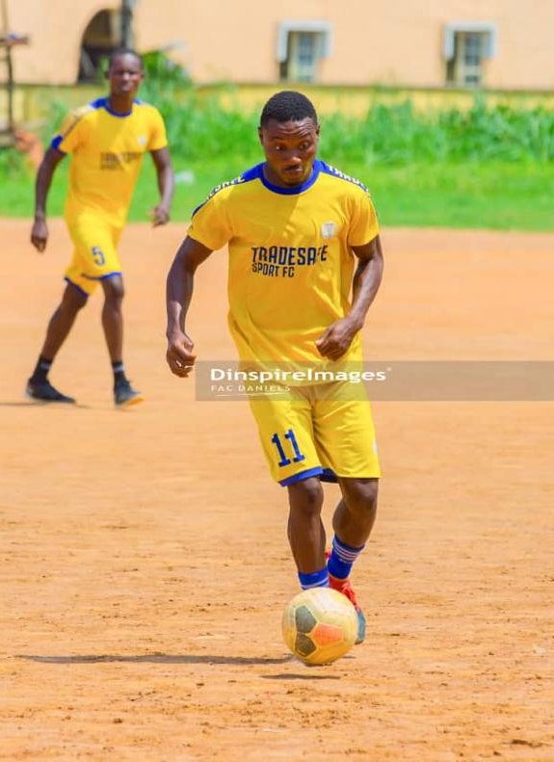
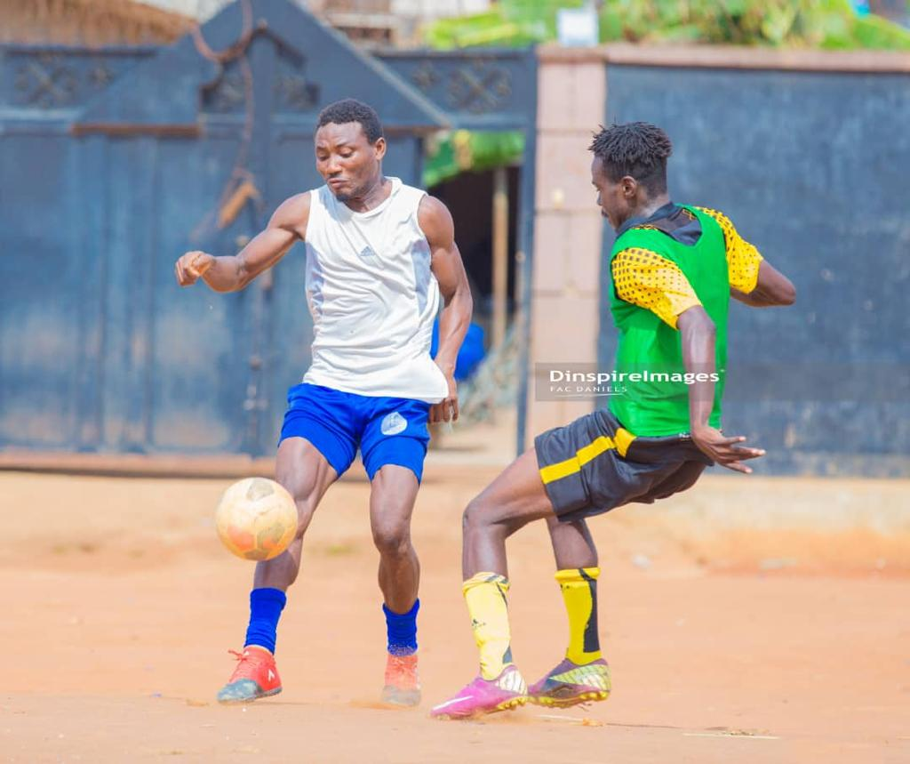
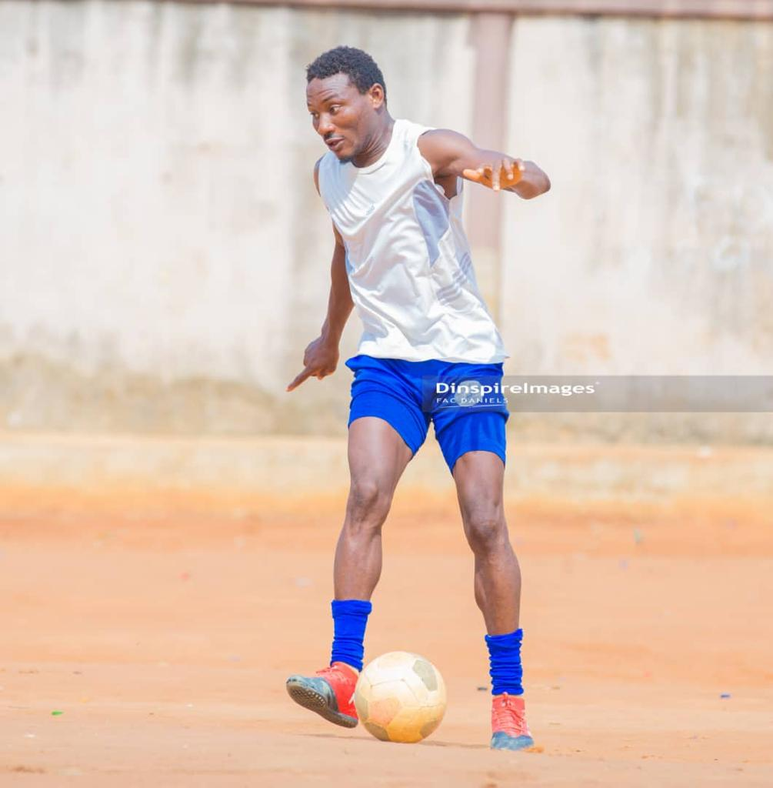

Honour:
2015/2016 Won Higher Goals Scorer.
2nd Place In The League
Most Valuable Player For Ramadan Cup 2016/2017 And Won The Cup

